**WeatherPy - Python API Homework Analysis -**

In this assignment, Python script and Google APIs are used to visualize the weather of more than 500 different cities worldwide in order to understand the relationship between the geographic coordinates of these cities and different models of weather patterns. From this analysis, three conclusions can be drawn:

**Conclusion 1: Cities with higher levels of humidity are located closer to the equatorial zones of the world**. This is no surprise as these regions are hotter than other regions on the planet. According to the graph below, several dozen cities located 40 degrees below and above the equator have higher humidity levels higher compared to other cities. However, there is a large grouping of cities located well north of the equator with humidity levels that match those cities and regions closer to the equator. Further research can indicate the types of weather systems that are affecting these cities and why they result in high humidity levels.

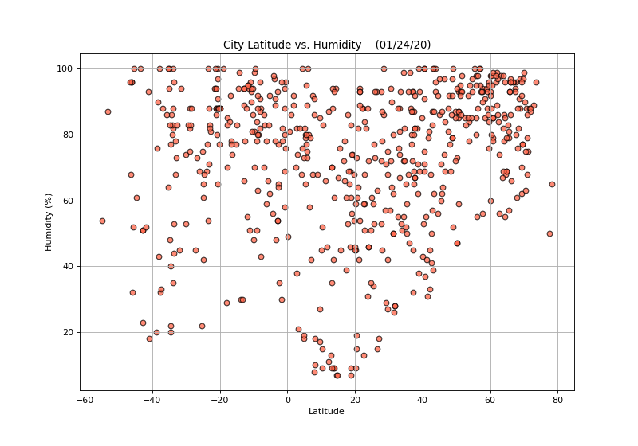

**Conclusion 2: Temperatures of different cities depend on their geographic location.** The closer a city is to the equator, the hotter it tends to be, as indicated by the graph below. A majority of the world’s cities are located between the [Tropic of Cancer and the Tropic of Capricorn,](https://study.com/academy/lesson/the-equator-the-tropics-of-cancer-capricorn-association-with-earth-sun-geometry.html) (23.5 N and 23.5 S). Those cities are located in more tropical regions, while the cities located 40 degrees below and above the equator are colder. The linear regression graph between temperature and latitude supports the trend of the latitude versus temperature graph, indicating a negative correlation between the two points. Air temperature decreases as you travel through higher latitudes.

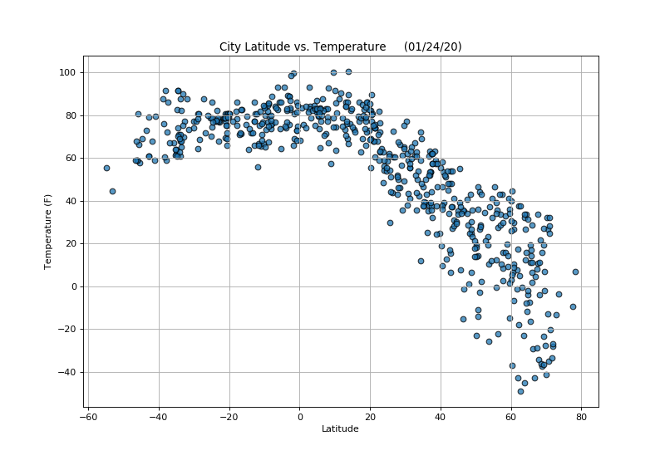

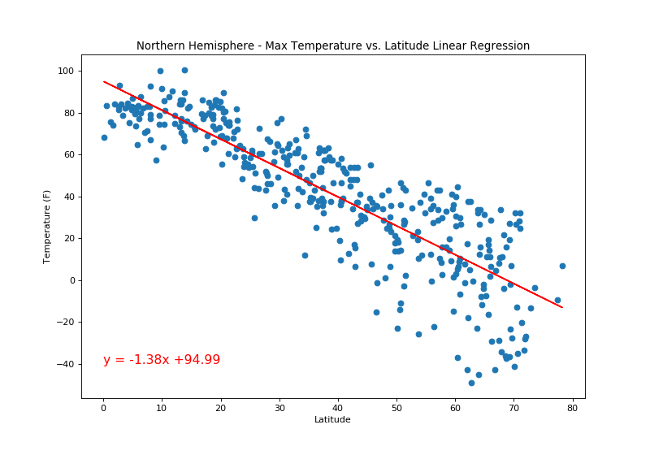

**Conclusion 3: There is no real relationship between a city’s geographic location and wind speed.** As shown in the graph below, slight winds prevail for most of the world’s cities. Also known as the [doldrums,](https://oceanservice.noaa.gov/facts/doldrums.html) the areas located less than 10 degrees north and south of the equator are known for having relatively calm winds. Most of the cities analyzed endure winds 10 mph or less.

